Unit 1 - Foundations of Computing and Digital Systems

1 Computing in Everyday Life

How do computers process information, and what role does logic play in their decision-making?

2 Introduction to Computing

How has computing evolved from early mechanical systems to AI-driven automation?

Case study - compare and contrast Colossus vs my laptop

“Colossus incorporated 1500 valves, and operated in parallel arithmetic mode at 5000 pulses per second. Some of its features have been disclosed, including the fact that it had prodigiously fast (5000 characters per second) paper tape inputs, electronic counting circuits, binary arithmetic and Boolean logic operations, “electronic storage resisters changeable by an automatically controlled sequence of operations”, “conditional (branching) logic”, “logic functions pre-set by patchpanels or switches, or conditionally selected by telephone relays”, and typewriter output.” (Randell, 1982)

Feature | Colossus (1943–44) | My HP OMEN Transcend 14
Era | World War II | 2025
Primary purpose | Codebreaking (Lorenz cipher) | General-purpose computing
Programmability | Semi-programmable via switches & patch panels | Fully programmable (software)
Logic system | Binary, Boolean logic | Binary, Boolean logic
Arithmetic mode | Parallel arithmetic (fixed function) | Parallel, superscalar, vectorized
Clock / speed | ~5,000 pulses per second | ~2.5–5+ billion cycles per second
Processing units | Single electronic processing system | 16 CPU cores / 22 threads
Components | ~1,500 vacuum valves (tubes) | Billions of transistors
Physical size | Room-sized | Portable laptop
Power consumption | Kilowatts | Tens of watts
Memory (working storage) | Electronic counters & resistors | 32 GB RAM
Program storage | None (hardware-configured) | Software on SSD
Input | Paper tape (5,000 chars/sec) | Keyboard, mouse, touchpad, network
Output | Typewriter / printer | High-resolution display, audio, files
Branching logic | Conditional (limited) | Fully dynamic branching
Reconfiguration time | Minutes to hours | Milliseconds
Reliability | Frequent component failures | High stability
Virtualisation | None | Hardware-assisted virtualisation
Security features | None | Secure Boot, VBS, HVCI

(OpenAI, 2026)

What are the key differences between classical and quantum computing?
Classic computing is 1 or 0, quantum computing is 1, 0 or both.
Quantum computing is still experimental and in the testing stages where as classic computing is established.
Quantum computing can theoretically iterate more problems and possible solutions.

How do computing technologies shape industries like healthcare, finance, and cybersecurity?
Cybersecurity wouldn’t exist without computers… It wouldn’t be needed.

Healthcare, data analysis is a huge part. Store manage and calculate individual and large groups of data. It can be used for meta analysis.
Additionally early screen of scans and images for cancer and other conditions.

Finance: instantaneous exchange of data, funds, stock prices, and trades. Communication across continents in real time.
Increase in data break and cyber attacks.
Invention of new forms of currency that are unregulated, such as bitcoin.

3 Logic, Gates and Boolean Algebra

Basic Logic Gates (AND, OR, NOT, XOR, NAND, NOR).

Truth Tables and Boolean Expressions.

AND
Both must be 1
A · B
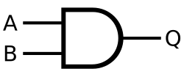

A | B | Output

0 | 0 | 0

0 | 1 | 0

1 | 0 | 0

1 | 1 | 1

OR
At least one is 1
A + B

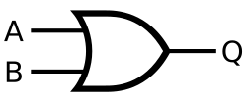
A | B | Output
0 | 0 | 0
0 | 1 | 1
1 | 0 | 1
1 | 1 | 1

NOT
Flips input
¬A or A'
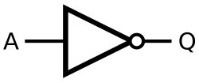
A | Output
0 | 1
1 | 0

XOR
Must be different
A ⊕ B

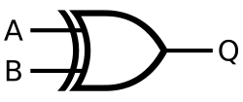
A | B | Output
0 | 0 | 0
0 | 1 | 1
1 | 0 | 1
1 | 1 | 0

NAND
Opposite of AND - both 1 = 0 otherwise 1
¬(A · B)
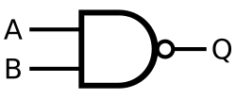

A | B | Output
0 | 0 | 1
0 | 1 | 1
1 | 0 | 1
1 | 1 | 0

NOR
Opposite of OR: both must be 0, otherwise 0
¬(A + B)
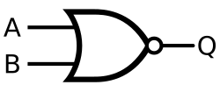

A | B | Output
0 | 0 | 1
0 | 1 | 0
1 | 0 | 0
1 | 1 | 0

How logic gates form the basis of microprocessors.

Activity: Students will construct truth tables for simple Boolean expressions and determine outputs for given digital circuits.

Y=NAND(A,B) AND (B XOR C)
A | B | C | NAND | B XOR C | Result
0 | 0 | 0 | 1 | 0 | 0
0 | 0 | 1 | 1 | 1 | 1
0 | 1 | 0 | 1 | 1 | 1
0 | 1 | 1 | 1 | 0 | 0
1 | 0 | 0 | 1 | 0 | 0
1 | 0 | 1 | 1 | 1 | 1
1 | 1 | 0 | 0 | 1 | 0
1 | 1 | 1 | 0 | 0 | 0

Y=NOR(A,B) XOR (A AND C)
A | B | C | NOR A B | A AND C | Result
0 | 0 | 0 | 1 | 0 | 1
0 | 0 | 1 | 1 | 0 | 1
0 | 1 | 0 | 0 | 0 | 0
0 | 1 | 1 | 0 | 0 | 0
1 | 0 | 0 | 0 | 0 | 0
1 | 0 | 1 | 0 | 1 | 1
1 | 1 | 0 | 0 | 0 | 0
1 | 1 | 1 | 0 | 1 | 1

Y=((A XOR B) AND (C NOR D)) OR (NAND(A,C) AND ¬B)
A | B | C | D | A XOR B | C NOR D | NAND(A,C) | NOT B | Term1 | Term2 | Y
0 | 0 | 0 | 0 | 0 | 1 | 1 | 1 | 0 | 1 | 1
0 | 0 | 0 | 1 | 0 | 0 | 1 | 1 | 0 | 1 | 1
0 | 0 | 1 | 0 | 0 | 0 | 1 | 1 | 0 | 1 | 1
0 | 0 | 1 | 1 | 0 | 0 | 1 | 1 | 0 | 1 | 1
0 | 1 | 0 | 0 | 1 | 1 | 1 | 0 | 1 | 0 | 1
0 | 1 | 0 | 1 | 1 | 0 | 1 | 0 | 0 | 0 | 0
0 | 1 | 1 | 0 | 1 | 0 | 1 | 0 | 0 | 0 | 0
0 | 1 | 1 | 1 | 1 | 0 | 1 | 0 | 0 | 0 | 0
1 | 0 | 0 | 0 | 1 | 1 | 1 | 1 | 1 | 1 | 1
1 | 0 | 0 | 1 | 1 | 0 | 1 | 1 | 0 | 1 | 1
1 | 0 | 1 | 0 | 1 | 0 | 0 | 1 | 0 | 0 | 0
1 | 0 | 1 | 1 | 1 | 0 | 0 | 1 | 0 | 0 | 0
1 | 1 | 0 | 0 | 0 | 1 | 1 | 0 | 0 | 0 | 0
1 | 1 | 0 | 1 | 0 | 0 | 1 | 0 | 0 | 0 | 0
1 | 1 | 1 | 0 | 0 | 0 | 0 | 0 | 0 | 0 | 0
1 | 1 | 1 | 1 | 0 | 0 | 0 | 0 | 1 | 0 | 1

4 Set Theory in Computing (20 minutes)

What are sets, subsets, intersections, and unions in computing?
Set - collection of things: [Dog, Cat, Rabbit, Fox]
⊆ Sub Set - Part of another collection: [Cat, Fox]
∩ Intersections - things in both: [Cat, Dog, Fox] [Dog, Rabbit, Cat] = [Dog, Cat]
∪ Unions - two sets joined without duplication: [Cat, Dog, Fox] [Dog, Rabbit, Cat] = [Dog, Cat, Rabbit, Fox]
Math | Python | JavaScript
Set | {1,2,3} | new Set([1,2,3])
∈ | x in A | A.has(x)
⊆ | A <= B | manual function
∪ | `A | B`
∩ | A & B | filter + has()

How does set theory apply to relational databases and search algorithms?
Can be used to filter data. For example mailing list subscribers that are subscribed to important notifications only.
Or patents of indian origin with a higher risk of diabetes.
Removes duplicates, e.g. users that downloaded the software more than once, or logged in from multiple machines.

Can be used for searching, e.g. articles about Trump in the last 24 hours.

Pages that have both keyword - are in both lists - intersections

Filtering, e.g. Clothing - shoes that are pink, in size 44 and trainers.

Appointments available today or tomorrow.

What role does set theory play in artificial intelligence and big data analytics?
Activity: Construct Venn diagrams to represent database queries and search engine indexing.
Solve a real-world data structuring problem using set operations.

Advertise a garage to people in Grimsby:
Car Drivers ∩ People in Grimsby

Find all External Doors and Windows to mark fire escapes:
(External Doors ⊆ Doors) ∪ Windows

Find the latest news about Trump
News articles about Trump ∩ From the last 24 hours

Drawings created in version 1 & 2:
Drawings created in version 1 ∪ Drawings created in version 2

Patents that need a check up reminder
patents that have not had a check up in the last year. ⊆ Patents
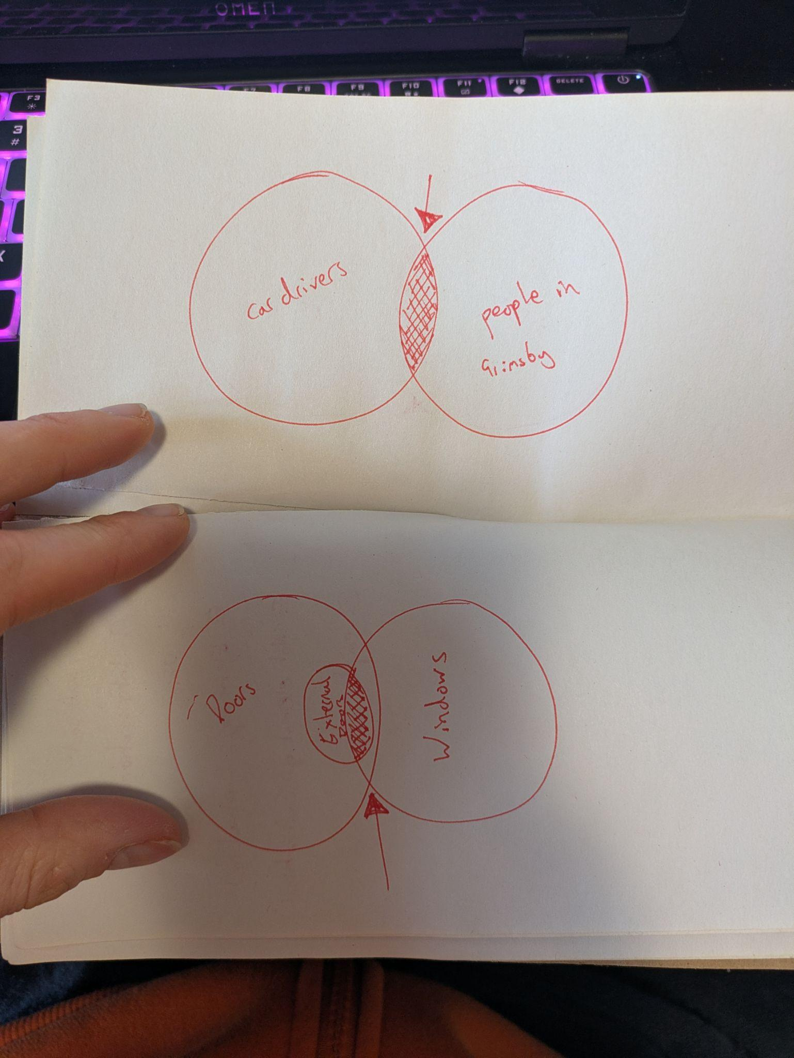

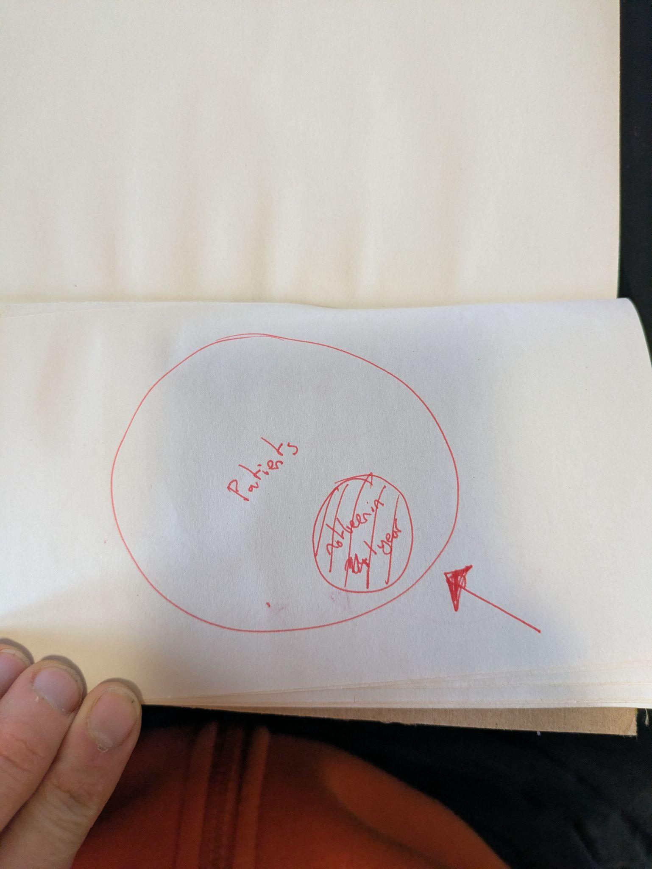
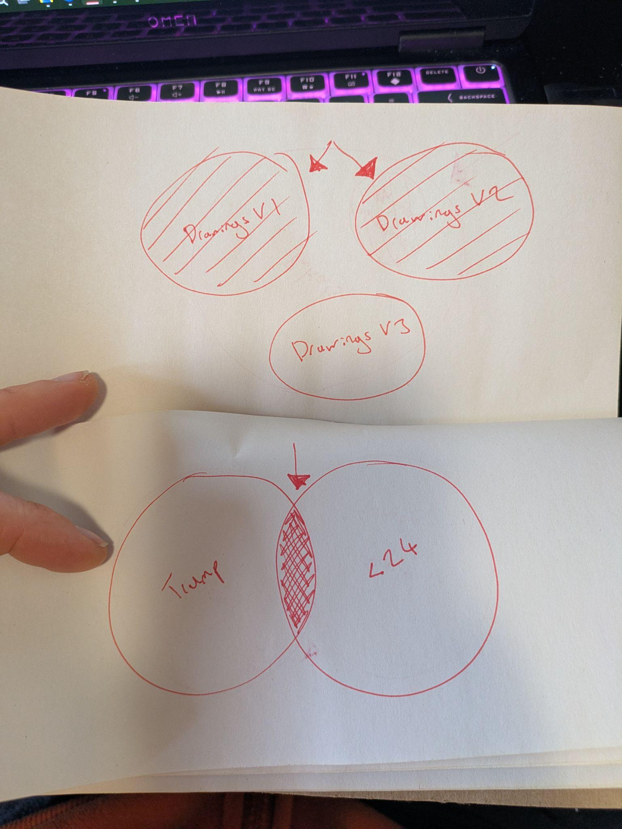

References

OpenAI, 2026. Comparison of the Turing Colossus computer and a modern home laptop (HP Omen). ChatGPT conversation. Available at: https://chatgpt.com/share/698362bc-eeec-8008-8eb8-1a86938c6869
(Accessed: 4 February 2026).

Randell, B. (1982). Colossus: Godfather of the Computer. In: Randell, B. (eds) The Origins of Digital Computers. Texts and Monographs in Computer Science. Springer, Berlin, Heidelberg. Available at: https://doi.org/10.1007/978-3-642-61812-3_27 (Accessed: 4th February 2026).

